Seismic Performance-based Design of Water Distribution Systems Considering the Comprehensive Importance of Users

HOU Benwei1, DU Xiuli2, LI Xiaojun1, 2, LIU Aiwen1

1. Institute of Geophysics, China Earthquake Administration, Beijing 100081, China;

2. Key Laboratory of Urban Security and Disaster Engineering of Ministry of Education, Beijing University of Technology, Beijing 100124, China.

**Abstract** The seismic design of water distribution systems (WDSs) is essential to secure their post-earthquake serviceability. This paper presents a framework for the seismic performance-based design of WDSs, as implemented by an optimization design model of a pipeline network. The performance objective is determined according to the seismic performance requirements of user nodes with various importance values. Design variables consist of the topology of the pipeline network and the seismic resistance capacities of the pipeline structures. The parameters of these variables are determined by an improved seismic optimization design model. A comprehensive assessment model to evaluate the importance of user nodes is established by considering the normal service function, post-earthquake relief function and network topology influence. Moreover, the seismic performance-cost curve of the pipeline structure is presented according to the relations between the seismic reliability and its corresponding cost. The proposed model was implemented in the seismic design of an actual WDS. The results show that the importance classifications of user nodes by comprehensive measures are more reasonable than those based on a single index. The optimal network topology and seismic resistance capacities of pipelines, as obtained by the proposed performance-based design model, can be treated as the basis for the seismic fortification and retrofitting of WDSs.

**Keywords** Seismic performance-based design; Water distribution system; Network reliability optimization; Comprehensive importance of users; Seismic performance-cost curve of pipelines

# Introduction

Urban water distribution systems (WDSs) consist of aqueducts, water treatment plants, pump stations, and water distribution pipelines. When suffering an earthquake attack, the seismic disaster to the WDS spreads as follows. Pipelines or station facilities are first subjected to structural damage. The serviceability of the WDS, including both the water pressure and the amount of water available, is damaged or totally lost then, which finally results in the serviceability not being able to satisfy the post-earthquake water demand. Therefore, the seismic design of a WDS should include both the seismic resistance of the pipeline structures and the seismic performance of the pipeline network.

In the development of the seismic design methodology of buildings, performance-based design has become a smart design philosophy (Ghobarah 2001; Ganzerli et al. 2000). The performance-based design objectives of these methods are focused on the specific performance requirement of each building rather than general requirements of structures. Similar to this design philosophy, there are also performance requirements of system serviceability in seismic design codes or guidelines of WDSs. In the Japanese seismic design guideline for water systems (JWWA, 2009), pipelines are classified according to their functional importance during different time periods after an earthquake. The performance requirements and seismic loads for the design of pipeline structures are determined based on these classifications. The post-earthquake serviceability requirements of users in WDSs are also provided in JWWA guidelines. In the American seismic guidelines for water pipelines (ALA, 2005) and the Indian guidelines for the seismic design of buried pipelines (IITK-GSDMA, 2007), pipelines are classified according to the importance of their normal service function and post-earthquake relief function, and the seismic loads for the design of pipeline structures are determined by these pipeline classes. The Chinese seismic design code for oil and gas transmission pipelines (GB50470 2008) adopted the classifications of the ALA (2005) guidelines. Although there is no similar pipeline classification in the Chinese seismic design code for water supply systems (GB50032 2003), available recommendations by Guo et al. (2007) indicate that WDSs should maintain a relief function under a destructive earthquake.

The design objectives of the above seismic design guidelines and codes include both pipeline structural safety and WDS serviceability after an earthquake. However, the current design methods provided by those guidelines and codes are limited to the structural parameters of pipelines; there is no quantized design method to verify the WDS post-earthquake serviceability requirements. For an existing pipeline network of a WDS, the system seismic serviceability can be evaluated by a network reliability analysis (Lim and Song, 2012), network redundancy assessment (Hoshiya et al. 2004) or hydraulic simulation (Romero et al. 2010; Wang et al. 2010; Liu et al. 2015). These evaluation methods can also be utilized in the seismic design of WDSs. One way to apply the system serviceability evaluation methods into the design of pipeline structures is using optimization. According to the WDS optimization design model for normal operation (Kapelan and Savic, 2005; Kadu et al. 2008; Jung et al. 2013), many seismic optimization models (Tan and Shinozuka 1982; Chen et al. 2002; Li. 2005; Li and Liu 2008; Yoo et al. 2016) for WDSs have been proposed to find the optimal network topology or pipeline diameters, subject to the connective reliability or water pressure constraints of users. However, the reliability or water pressure constraints of all users were usually set equal in these optimization models; none of these models consider the seismic demand individuations of users according to their importance classification. The decision variables of these optimization design models were the diameters of the pipelines, which are important factors affecting the hydraulic performance of the WDS, but cannot provide seismic resistance requirements for the structural design of the pipelines.

In this paper, we present a framework for the seismic performance-based design of WDSs by considering the importance classification of users and including the seismic resistance requirements of pipelines as decision variables in an improved optimization design model. The importance assessment model of users is established by considering normal operation and post-earthquake functional requirements. The seismic resistance variety of pipeline structures and its impacts on costs are illustrated by seismic performance-cost curves of a ductile iron pipeline with socket joints.

The rest of this study is organized as follows. The framework for the seismic performance-based design of WDSs is described in section 1. A comprehensive model to evaluate the importance values of users is provided in section 2. The seismic resistance performance-cost curves of pipelines are illustrated in section 3. An improved seismic optimization design model considering the seismic demand individuations of users is proposed in section 4. Section 5 presents the application results of a case study, in which the network topology and structural resistance requirements of pipelines are determined for seismic security purposes.

# 1 Framework for seismic performance-based design of WDSs

The layout of WDS pipelines can be represented by an algebraic network. In the network, pipelines are treated as arcs, purified water treatment plants are treated as source nodes, and the centralized water supply point and the crosses or tees of pipelines are treated as user nodes. Arcs may suffer damage due to seismic damage to the pipeline structure. Nodes are assumed to be perfectly reliable. Fig. 1 shows the flowchart of the seismic performance-based design model proposed by this study. There are six main steps in the proposed model. The intention of each step is explained as follows. The seismic performance objective of the WDS should be proposed by the functional requirements of user nodes rather than the structural resistance of pipelines. Therefore, the fortification criterion is first determined according to the importance classification of user nodes by step 1 and 2. The comprehensive importance values of user nodes are calculated in step 1, based on which the classification of user nodes can be executed. Among the system performance assessment methods that can be used as the post-earthquake performance criteria of user nodes, the network connective reliability of user nodes is chosen as the performance criterion. The performance objectives of user nodes with different importance classifications are determined in step 2 by the decision makers.

Importance classifications of user nodes considering post- earthquake function.

Determine seismic performance design objectives of user nodes.

Take the pipeline network topology and seismic resistance of pipeline structures as design variables.

Determine network topology layout, and assign the seismic resistance requirements of pipeline structures according to the seismic performance requirements of user nodes by optimization.

Specify the materials, joints and counter measures of pipeline structures according to the resistance requirements of pipelines.

Seismic performance analyses of pipeline structures and user nodes under scenario earthquakes.

Achieve the design objectives?

**N**

**Y**

The End

1. Importance classification

2. Seismic fortification criterion of user nodes

3. Design variable selection

4. Parameter assignment of design variables

5. Pipeline structure design

6. Design scheme assessment

**Fig. 1** Framework for seismic performance-based design of a water distribution system

Because the enhancement of the seismic performance of user nodes can be achieved through the redundancy layout of the water supply network and the seismic resistance improvement of pipeline structures, the seismic resistance requirements of the pipe structures and the network topology and are chosen as design variables in step 3. The constraints of the optimization model are the performance objectives of the user nodes, i.e., the seismic connective reliability of user nodes. These constraints cannot be expressed directly as a function of the design variables because of their non-linear relationship. With the help of the network reliability analysis, the seismic performance objectives are transformed into the requirements of the network topology and structural capacity of pipelines. The parameter determination of these variables is conducted in step 4. There are two possible strategies to handle the parameter assignment problem, one is design-check iteration, and the other is optimization. The former can find a design scheme that fulfills the performance objectives and other preferences of decision makers, but it may be not the minimum-cost scheme. The latter can find a minimum-cost scheme according to the performance objectives, and it is applied in this study. The seismic function class, material and joints of pipelines can be determined in step 5 to satisfy the seismic resistance requirements of pipeline structures by seismic response analysis.

This study focuses on steps 1, 3 and 4 of Fig. 1 and mainly provides solutions for the importance classification of users, design variable determination and parameter assignment of design variables.

# 2 Comprehensive importance of user nodes

The locations of the source nodes (water treatment plants) and user nodes are assumed predetermined by the WDS project planning of water works. Thus, the optimal locations of user nodes are not part of the work in this study. This section presents a comprehensive importance assessment model of users by considering their influence on normal service function, post-earthquake relief function and network topology. First, the degree of a user’s importance is independently calculated by three main indexes and their sub-indexes. Then, the comprehensive importance of the user nodes is calculated by a multi-criteria decision-making method based on the values of those indexes. The framework of the assessment model is presented in Fig. 2.

Comprehensive Importance of User Node, *I*

Normal operation function, *I*1

Post-earthquake relief function, *I*2

Network topology influence, *I*3

Demand in households, *I*11

Demand for industrial use, *I*12

Demand for public service, *I*13

Other demands, *I*14

Distance from source, *I*31

Betweenness centrality, *I*32

Contraction influence, *I*33

Demand for disaster relief, *I*21

Demand for secondary disaster control, *I*22

Demand in seismic shelter for evacuation, *I*23

Other demands, *I*24

**Fig. 2** Importance assessment indexes of user nodes

## 2.1 Importance indexes of normal operation

The daily water demands of an urban WDS consist of household demand, public service demand, industrial production demand, and other types of demand. These categories are taken as sub-indexes (*I*11, *I*12, *I*13, *I*14) to evaluate the normal operation importance index *I*1. The value of *I*1 equals the weighted sum of the water demands of the sub-indexes *I*1*j* (*i*=1,…,4). The water demand of the sub-indexes *I*1*j* can be calculated as follows: (i) for user nodes in built-up areas, the value can be taken from the statistical data of daily water consumption; (ii) for user nodes in urban planning areas, the value can be calculated according to the land type for construction and the unit water demand data provided by the Chinese code for urban water supply engineering planning (GB50282 1998). From the standpoint of the population affected by the interruption of the water supply, a user node serving a large population will hold a high degree of importance. Therefore, the importance rankings of these sub-indexes are assumed to be *I*13> *I*11> *I*12> *I*14. For the main index of normal operation importance *I*1, user nodes with a larger value hold a higher degree of integrated importance.

## 2.2 Importance indexes of post-earthquake relief function

During the period of post-earthquake relief and recovery, the water demands of user nodes may change significantly from those of normal operation. Water demands for daily services will certainly be reduced and may even disappear, while water demands for post-earthquake relief purposes will rise. The higher the earthquake intensity in the service area of the user node is, the larger its water demands will change. The priorities of post-earthquake water supply are user nodes located in areas for disaster relief, evacuation, and potential secondary disaster control. The water demands of these user nodes are more urgent than those of others. Therefore, the post-earthquake water demands of user nodes are divided as follows: demand for disaster relief facilities, demand for secondary disaster control, demand for seismic shelter for evacuation, and other demands. Those categories are taken as sub-indexes (*I*21, *I*22, *I*23, *I*24) to evaluate the post-earthquake relief importance (*I*2).

The sub-indexes *I*2*j* (*j*=1,…,4) of each user node can be calculated according to the layout and volume of the facilities it serves (facility method) or the land type and area it is located in (land type method). Table 1 shows the facility and land types for sub-indexes *I*2*j*.

**Table 1** Water demand for post-earthquake relief and disaster reduction

|  |  |  |  |  |
| --- | --- | --- | --- | --- |
| **Demand**  **type** | Disaster relief,  *I*21 | Secondary disaster control, *I*22 | Seismic shelter for evacuation, *I*23 | Other  demands, *I*24 |
| **Facilities** | Disaster relief headquarters, Hospitals, Transportation hub, etc. | Fire stations, Potential fire site, Explosive facilities, etc. | Green spaces, parks, squares, school playgrounds, large-scale sports stadiums, etc. | User node for households, commercial, industrial use, etc. |
| **Land** | Land for administrative facilities, Medical land, Transportation land, etc. | Fire control land, industrial land (partial), fuel and gas storage land, etc. | Green space and square, educational site, sports land, etc. | Residential, commercial, business and industrial land, etc. |

In the “facility” method, the locations and volumes should be pre-determined according to the results of the earthquake disaster prediction and urban planning on hazardous prevention. The post-earthquake water demands of those facilities can be calculated by their volumes and unit water demand quotas. In the “land type” method, the type of construction land, planned or existing, is partitioned by urban planning. The locations and service areas of user nodes are assumed to be determined by the WDS project planning of water works. The post-earthquake water demands of different lands can be calculated by their areas and unit water demand quotas, considering adjustment for post-earthquake function. After the location and volume determination of facilities or lands, the post-earthquake water demand of user nodes can be calculated by expression (1).

 (1)

where *Qi\** is the post-earthquake water demand of user node *i*, which is the sum of sub-indexes *I*2*k*(*i*)*. mk*(*i*) is the number of facilities that correspond to *I*2*k*(*i*), *Vij* is the volume of facility *j*, *gj* is the unit water demand of facility *j*, and *nk*(*i*) is the number of land types thatcorrespond to *I*2*k*(*i*). *Aij* is the service area of land type *j*, which can feasibly be determined by constructing Thiessen polygons of the user nodes in the map including the land types and locations of the user nodes. *qj* is the standard daily demand of land type *j*, provided by the Chinese code for urban water supply engineering planning (GB50282 1998), and *αj* is the post-earthquake adjustment coefficient for land type *j*.

Figure 3 presents an illustrative example WDS network to introduce the facility method. The network comprises six user nodes (1~6) and nine pipelines (A~G, H, L). The service facilities for each user node are presented in Fig. 3, as is the post-earthquake water demand constitution of user node 5. Fig. 4 presents the service land types of the user nodes in the example WDS network. To be consistent with the facility locations in Fig. 3, the land type assumptions in Fig. 4 are made according to Table 1. The post-earthquake water demand constitution of node 5 calculated by the land type method is also illustrated in Fig. 4.

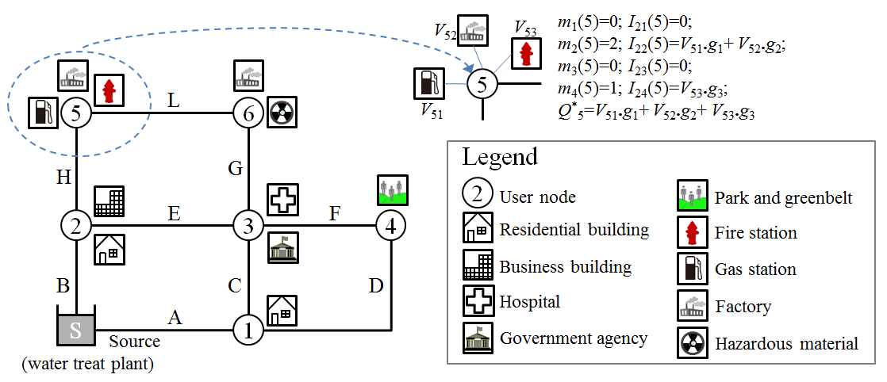

**Fig. 3** Layout of the example WDS network and service facilities of user nodes

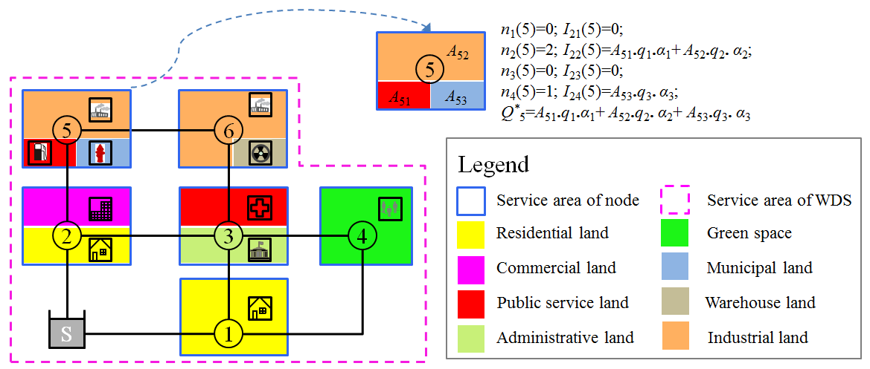

**Fig. 4** Service land types of user nodes in the example WDS network

According to the Chinese standard for urban planning on earthquake resistance and hazardous prevention (GB50413 2007), the minimum water supply requirements during the post-earthquake response are given in Table 2, showing how they change with time. The Japanese seismic design guideline for water systems (JWWA, 2009) also provides design objectives of per capita water supply quantities and supply patterns for different post-earthquake periods.

**Table 2** Per capita water requirements during post-earthquake response (GB50413 2007)

|  |  |  |  |
| --- | --- | --- | --- |
| **Post-earthquake period** | **Time** | **Per capita**  **(L/person. day)** | **Water usage** |
| Urgent rescue | 0~3 day | 3-5 | Drinking, medical care; |
| Emergency response | 4~7 day | 10-20 | Drinking, medical care, cleaning; |
| 8~30 day | 20-30 | Drinking, medical care, cleaning, bathing; |
| Post-earthquake recovery | >30 day | >30 | Lower level of daily demand, critical user node demand; |

The water demands of sub-indexes *I*2*j* will change with time. Taking sub-indexes *I*23 and *I*24 as an example, under a destructive earthquake, most residents will stay in seismic shelters for evacuation in the period of urgent rescue, so the value of *I*23 will be greater than that of *I*24. On the other hand, most residents may come home after the period of emergency response, so the value of *I*23 will be smaller than that of *I*24. To consider the changes in *I*2*j* in different post-earthquake periods, parameters *gj* and *αj* should take different values accordingly.

## 2.3 Importance indexes of network topology influence

When choosing a pipeline network topology, the critical pipelines in the network should be given priority. Three considerations are taken in the identification of critical pipelines. (i) Pipelines near the source node of the WDS network may be trunk lines with relatively large importance. (ii) Pipelines with a large number of visits by the shortest paths from the source to the user nodes may be critical. (iii) Pipelines that have a great impact on the connectivity from the source to the user nodes when interrupted are of great importance. The endpoints (i.e., start and end nodes) of critical pipelines can also have a great impact on the network topology. Therefore, the identification of critical user nodes is similar to that of pipelines. Three sub-indexes named the “source distance” (*I*31), “betweenness centrality” (*I*32) and “contraction centrality” (*I*33) of nodes are chosen to evaluate the topological importance of user nodes. A network model *G*(**V**,**E**) consisting of a set **V***=*{*v*1*,v*2*,…,vn* } of *n* nodes and a set **E***=*{*e1,e2,…,en* } of *m* (directed/undirected) arcs is utilized to represent the alternative network topology of the WDS. In the node set **V**, element *vs* denotes the source node of *G*, and *vt* denotes a user node.

(1) Source distance of user nodes (*I*31). In the network model of the WDS, the source distance of user node *i* is defined as the shortest distance from the source node to user node *i* with all arcs (pipelines) having a unit length:

 (2)

When all arcs in the network are set with a unit length, the value of *I*31(*i*) equals the arc number in the shortest path and can be calculated by the breadth first search (BFS) algorithm (West 2001). The *I*31(*i*) values of the user nodes in the example WDS network are presented in Fig. 5.

5

6

2

3

4

1

S

*I*31(5)=2;

*I*31(3)=2

*I*31(1)=1;

*I*31(2)=1

*I*31(6)=3

*I*31(4)=2

**Fig. 5** Source distances of user nodes in the example WDS network

(2) Betweenness centrality of user nodes (*I*32). The sub-index betweenness centrality (BC) has been widely used in the literature to assess element importance in infrastructure networks (Winkler et al. 2010; Duenas-Osorio and Vemuru 2009). The BC of node *vi* in an undirected network is deﬁned as the number of shortest path visits from node *vk* to *vj* (*k*≠*j*≠*i*; *vk*, *vj*∈**V**) (Brandes 2001). Because network flows in a WDS network are always directed flows from the source to user nodes, the WDS network is treated as a directed network. The BC of user node *i* in the WDS network is expressed as

 (3)

where Σ denotes the number sum of all shortest paths from the source to all user nodes except node *vi*. *Ns*→*j* is the number of shortest paths from source node *vs* to user node *vj* (*s*≠*j*≠*i*), and *Ns*→*j*(*i*) is the number of shortest paths from *vs* to *vj* passing through node *vi*. The shortest paths are calculated by the BFS algorithm, with the arc length determined by the geographical length of the alternative pipelines.

(3) Contraction centrality of user nodes (*I*33). According to the definition by Tan et al. (2006), the contraction centrality of node *i* based on the agglomeration index of the WDS network is expressed as

 (4)

where *G*\**vi* is the modified network topology of *G* after aggregation by node *vi,* and *ki* is the number of adjacent nodes of node *vi*.. 1/[*n***.***l*(*G*)] and 1/[(*n*-*ki*)**.***l*(*G*\**vi*)] are the agglomerations of networks *G* and *G*\**vi*, respectively. is the average path length of *G*, and *ds*→*j* is the length of the shortest path from node *vs* to *vj*. The length of arcs in G is determined by the geographical length of the pipelines. The aggregation of *G* by node *vi* is conducted by mixing all of its adjacent nodes and arcs within node *vi*. In the topologyof*G*\**vi*, the adjacent nodes and arcs of *vi* in G are replaced by node *vi*, and the arcs connecting those adjacent nodes in G are converted into the adjacent arcs of node *vi* in *G*\**vi*. Fig. 6 presents a topological illustration of *G*\**vi* based on the layout of the example WDS network.

5

3

4

1

S

B

C

A

D

**(a)**

E

G

F

5

3

S

**(b)**

A

B

H

L

**Fig.** **6** Topological aggregation of the example WDS network. **(a)** *G*\**v*5. **(b)** *G*\**v*3

Sub-index *I*31 indicates the primary and appurtenant relations of the trunk and branch pipelines in a WDS network. A user node near the source usually has a smaller value of *I*31(*i*) and is always located in trunk lines. BC index *I*32 indicates the overall impact on the WDS network topology. A user node that is passed through by a large number of shortest paths has a large value of *I*32(*i*). The contraction centrality index *I*33 indicates the local impact on the network topology. A user node with a large value of *I*33(*i*) possesses a higher degree of topological importance.

## 2.4 Methods to calculate the comprehensive importance of user nodes

Because there are three main indexes and eleven sub-indexes to assess the importance of user nodes in Fig. 2, a multi-criteria decision-making method named “technique for order preference by similarity to an ideal solution” (TOPSIS) is utilized to calculate the integrated importance based on the values of sub-indexes. TOPSIS is a popular method to identify comprehensive solutions from a set of elements based on the simultaneous minimization of the distance from an ideal point and the maximization of the distance from a nadir point (Kim et al. 1997; Mukherjee and Nath 2005) and has been applied to the element ranking of complex systems (Certa et al. 2013).

Index weights should be determined before the implementation of the TOPSIS method. According to the characteristics of the main indexes and their sub-indexes, an improved analytic hierarchy process (AHP) method based on element ranking (Zhu et al. 1999) is utilized to evaluate the weights of indexes *Ii*, *I*1*j* and *I*2*j*(*i* = 1, 2, 3; *j* = 1, 2, 3, 4). The main steps of the improved AHP are as follows: (i) Determine the importance ranking of indexes. (ii) Construct a judgment matrix by three scaling values (0, 1 and 2) according to the ranking. For element *mij* in the judgment matrix, *mij*=2 if index *i* is more important than index *j*, *mij*=1 if index *i* and index *j* hold equal importance, and *mij*=0 if index *i* is less important than index *j*. (iii) Construct a comparison matrix based on the range method. The relative importance values of the ranges for indexes *Ii*, *I*1*j* and *I*2*j* are taken as 2, 3 and 3, respectively. (iv) Evaluate the weights of the indexes after the consistency check. This study focus on the seismic importance of user nodes, so the importance rankings of the main indexes are assumed to be *I*2>*I*1=*I*3. The post-earthquake disaster mitigation activities of the 2008 Wenchuan earthquake show that the water demands of seismic congregate shelters are the most urgent requirements to be satisfied during the period of the emergency response (Wang et al. 2009; Liu and Zheng 2013), so the importance rankings of sub-indexes *I*2*j* are taken as *I*23>*I*21>*I*22>*I*24. According to the importance rankings of index sets *Ii*, *I*1*j* and *I*2*j*, the separate weights of each set and the integrated weights of the sub-indexes are shown in Table 3. The integrated weights *wij\** of the sub-indexes are calculated by *wij\**= *wi*×*wij* .

**Table 3** Separate and integrated weights of indexes

|  |  |  |  |  |  |  |  |  |  |
| --- | --- | --- | --- | --- | --- | --- | --- | --- | --- |
| **main indexes** | ***I*1** | | | | ***I*2** | | | | ***I*3** |
| **weights (*wi*)** | 0.25 | | | | 0.50 | | | | 0.25 |
| **sub-indexes** | ***I*11** | ***I*12** | ***I*13** | ***I*14** | ***I*21** | ***I*22** | ***I*23** | ***I*24** | ***I*3*j*** |
| **weights (*wij*)** | 0.2765 | 0.1917 | 0.3988 | 0.1330 | 0.2765 | 0.1917 | 0.3988 | 0.1330 | - |
| **integrated**  **weights (*wij\**)** | 0.0691 | 0.0479 | 0.0997 | 0.0332 | 0.1383 | 0.0959 | 0.1994 | 0.0665 | - |

For the weights of sub-indexes *I*3*j* (*j*=1, 2, 3), an objective weight method based on information entropy (IE) is utilized to calculate the weights of *I*3*j*. According to the IE method (Zou et al. 2006), the weight of an index is correlated with the assessment values of its alternatives, so the weights of sub-indexes *I*3*j* are not presented in Table 3, but they will be provided in the case study.

When applying the TOPSIS method for the importance ranking of user nodes, each user node is treated as an element, and sub-indexes are treated as the decision criteria of elements. The assessment of the comprehensive importance of user nodes is then transformed into a multi-criteria decision-making problem. The decision criteria are the comprehensive values of elements, i.e., the comprehensive importance of user nodes. For the detailed steps of the TOPSIS method, see Kim et al. (1997) and Certa et al. (2013). The relative closeness to the ideal solution provided by the TOPSIS analysis is the value of the comprehensive importance of each user node.

# 3 Seismic performance-cost curve of pipeline structures

The seismic performance (resistance capacity) of pipelines is affected by the materials, joint types, and site conditions; there are notable diversities in the seismic performance of pipelines with different structural parameters. The seismic reliability is used to express the seismic performance of pipeline structures in this study. An illustration of the seismic performance-cost (PC) curve of pipelines is presented in Fig. 7. Similar to the curve of the reliability index versus cost of structures (Ditlevsen and Madsen 1996), the cost of a unit reliability improvement gradually increases with the increment of reliability, resulting in the slope of the curve gradually decreasing. In Fig. 7, point 1 (*c*1, *p*1) and point 4 (*c*4, *p*4) correspond to the lowest and highest seismic reliabilities of a pipeline structure, respectively. If the cost intervals from point 1 to 4 are assumed equal, i.e., *C*4-*C*3 = *C*3- *C*2 = *C*2-*C*1, then *p*4-*p*3 <*p*3-*p*2 <*p*2-*p*1. If we name the reliability (*p*1) and cost (*C*1) of point 1 as the reference seismic capacity and reference cost, respectively, the cost of the pipelines in other reliability states can be expressed by *C*1 and a cost adjustment coefficient *φi* (*φi*=*Ci*/*C*1; *i*=1,…,4).

**Construction cost**

***C*1**

**Seismic reliability**

***C*2**

***C*3**

***C*4**

***p*1**

***p*2**

***p*3**

***p*4**

**1**

**2**

**3**

**4**

**Fig. 7** Illustration of seismic performance-cost curve of pipeline structures

Factors affecting the seismic reliability of a pipeline may hold various values, resulting in a variation of the reliability. The costs and reliabilities of those alternative options produce the seismic PC curve of the pipeline. When implemented in seismic design, the PC curves of pipelines always consist of discrete points rather than a continuous curve due to the limited options for pipe materials, joints and other factors.

A ductile iron pipeline (DIP) with rubber joints is currently widely used in China. Fig. 8 presents the seismic performance-cost curves of a DN500 DIP with rubber joints buried in site condition type III (140<*Vs*20≤250 m/s). Different curves correspond to pipeline responses to different fortified seismic intensities in the Chinese seismic design code for water supply systems. The corresponding peak ground accelerations (PGAs) of Chinese seismic intensities (SIs) VII, VIII and IX are 0.1 g, 0.2 g and 0.4g, respectively. In the seismic response analysis of buried pipelines, DIPs with rubber joints are usually categorized as segmented pipelines (O’Rourke and Liu 2012), with seismic damage frequently occurring at joints, tees and elbows. The diameter and thickness of the DN500 DIP are 528 mm and 14.2 mm, respectively, and the standard segment length of the DIP is 6.0 m. The maximum joint movement response to SIs VII, VIII and IX of the DIP are calculated by the ground strain caused by seismic wave propagation and the length of the pipeline segment. For an introduction to the seismic response analysis of buried pipelines, see O’Rourke and Liu (2012), Li (2005). According to tensile test data of DIP rubber joints, the mean value and standard deviation of the allowable movement of DIP rubber joints are 5.59 mm and 0.76 mm, respectively (Li 2005). These allowable values are treated as the reference seismic capacity of the DIP (*C*1, *φ*1; *φ*1=1.0). If we assume that the allowable movement of the DIP joint increases to 1.4, 1.7, 2.0 and 2.2 times the reference capacity by special countermeasures of earthquake-resistant joints, the corresponding cost adjustment coefficients are 1.4, 1.8, 2.2 and 2.6, respectively. Then, the seismic reliabilities of DIP joints with different allowable movements under different SIs can be calculated according to structural reliability theory (Ditlevsen and Madsen 1996; Li 2005). The relationships between the seismic reliabilities and cost adjustment coefficients are shown in Fig. 8. The reliability of the reference seismic capacity has reached 1.0 in the curve of SI VII, so it is not necessary to improve the seismic resistance capacities of the DIP joints. On the curve of SI IX, the reliability of the reference seismic capacity is 0.237. When applying the special countermeasures of earthquake-resistant joints, the reliability of the DIP increases dramatically, and the slope of the curve decreases gradually.



**Fig. 8** Seismic performance-cost curves of the ductile iron pipeline

# 4 Optimal parameter assignments of design variables

## 4.1 Seismic optimization design model

Table 4 presents a comparison of existing optimization models for the seismic design of a WDS network. Because the network topology and the seismic resistance requirement of pipe structures are design variables of the proposed seismic performance-based design model, the optimization model should take these variables as decision variables. All of the optimization models were conducted on the alternative network topology, with possible pipeline routes predetermined by the project planning of water works. Therefore, the total number of pipelines may decrease but never increase as a result of such optimization.

**Table 4** Comparison of seismic optimization design models

|  |  |  |  |
| --- | --- | --- | --- |
| **Model** | **Find:**  (decision variables) | **So that:**  (optimization objective) | **Subject to:**  (constraints) |
| Tan and  Shinozuka (1982) | Network topology;  Pipeline diameters | Minimize WDS total cost | *H*(*i*)≥[*H*min], Nodal water pressure;  *Q*(*i*)≥[*Q*min], Nodal available water; |
| Chen et al. (2002);  Li (2005) | Network topology;  Pipeline diameters; | Minimize pipeline network cost | *β*(*i*)≥[*β*min], Nodal reliability index of Prob{*H*(*i*)≥[*H*min]} |
| Li and Liu (2008) | Network topology | Minimize pipeline network cost | *p*(*i*)≥[*p*min], Nodal connective reliability |
| Liu et al. (2012) | Network topology | Minimize annual equivalent cost | *β*(*i*)≥[*β*min], Nodal reliability index of Prob{*H*(*i*)≥[*H*min]} |
| Yoo et al. (2016) | Pipeline diameters | Minimize pipeline network cost;  Maximum network seismic reliability; | *H*(*i*)≥[*H*min], Nodal water pressure;  *Ck* ≥[*C*limit], Pipeline cost limit; |
| This study | Network topology;  Pipeline seismic resistance capacity; | Minimize pipeline network cost | *P*(*i*)≥[*P*(*i*)], Nodal connective reliability;  *R*(*i*)≥[*R*(*i*)], Nodal connective redundancy; |

Based on the optimization model by Li and Liu (2008), this section presents an improved seismic optimization design model considering the importance variety of user nodes and the seismic resistance capacity diversity of pipelines. The improvements in the model include that a specific constraint value is appointed for each user node rather than a general constraint for all user nodes, and the seismic resistance capacities of the pipelines are treated as decision variables. The improved optimization model is expressed as

 (5)

where *C* is the total construction cost of all pipelines in WDS, *c*(*li*, *di*) is the construction cost of pipeline *i*; and *li* and *di* denote the length and diameter of pipeline *i*, respectively. *γi* is an indicative function, where *γi* =1 if pipeline *i* is paved, and *γi* =0 if pipeline *i* is not selected. *φi* is the cost adjustment coefficient of pipeline *i*, whose value is dependent on the material and the joint type of the pipeline structures and related to the seismic capacity of the pipelines (see section 3). *Pj* is the seismic reliability requirement of user node *j*, which can be evaluated by Monte Carlo simulation (Ramirez and Coit 2005) or a recursive decomposition algorithm (Li 2005; Lim and Song 2012) according to the network topology and seismic reliabilities of the pipeline structures. *Rj* is the connective redundancy demand of user node *j*, whose value is related to the number of adjacency arcs. The node degree is taken as the redundancy metric in this study; illustrations of this parameter are presented in Fig. 9. [*Pj*] and [*Rj*] are the constraints of seismic reliability and redundancy in the optimization model, respectively, i.e., the seismic performance objectives of a WDS network. The values of [*Pj*] and [*Rj*] for different user nodes should be determined according to their importance classes.

5

6

2

3

4

1

S

1

1

2

4

2

1

**(a)**

5

6

2

3

4

1

S

2

3

2

4

3

2

**(b)**

**Fig. 9** Illustration of node degree in a pipeline network. **(a)** branched network with low redundancy. **(b)** looped network with high redundancy.

## 4.2 Solution algorithm for the optimization model

The optimization model (expression (5)) is a combinatorial optimization problem and can be solved through a variety of intelligent optimization algorithms. For the seismic topology optimization model of the WDS network, Liu et al. (2012) made a efficiency comparison of four algorithms, including the genetic algorithm (GA), simulated annealing genetic algorithm (SAGA), ant colony algorithm and particle swarm algorithm. The test results showed that the searching performance of SAGA is the best. SAGA is believed to keep the merits of the parallel searching structure of GA and the probabilistic jumping property of simulated annealing (SA), and it is utilized to solve the optimization model in this study. The main difference between GA and SAGA is that the mutation operation of GA is replaced by the SA algorithm. The main steps of SAGA for optimization include: (1) Coding. (2) Generating initial populations. (3) Evaluating the fitness of populations. (4) Generating operators: selection and crossover. (5) Population mutation by simulated annealing algorithm. (6) Stop criterion. For the general processes of SAGA, see Kardu et al. (2008) and Liu et al. (2012). The distinct processes and specific considerations for the optimization model in this study are described as follows.

Coding. There are two types of design variable in the optimization model, including the water supply network topology and the seismic capacity of the pipeline structures. The former is represented by an indicative function of alternative pipelines that takes the value of {0, 1}, and the latter takes discrete values due to the limited options for structural parameters. Therefore, the integral-coding method is applicable. For a WDS network with *m* alternative pipelines, a vector consists of *m* integers, where **x***i*={*xi*1,*xi*2,…,*xim*} represents an individual (chromosome) of GA population **X**={**x**1,**x**2,…,**x***N*}T, i.e., a possible solution of the optimization model. The value of gene *xij* indicates both the selection judgment and the seismic resistance capacity of the alternative pipeline *j*. For a pipeline with four possible values of seismic capacity, the possible value set of *xij* is {0,1,2,3,4}, where *xij*=0 indicates that pipeline *j* is discarded, and *xij*={1,2,3,4} represents the corresponding seismic resistance capacities of the selected pipeline *j* of vector **x***i*.

Constraint handling and fitness function definition. A penalty function is used to address constraints in the optimization model. The penalty function is designed to penalize infeasible solutions to reduce their ﬁtness and convert the constrained optimization model into an unconstrained one. The penalty function and the fitness function of an individual are expressed as

 (6)

 (7)

where *Pen*(*i*) is the value of the penalty function of individual **x***i*, *pk*(*i*) is the penalty value for the violation of the *k* th constraint, and *NC*=2 is the number of constraints in the optimization model. *Nk*(*i*) is the number of user nodes keeping the *k* th constraint, *Ck*(*i*) is number of user nodes satisfying the *k* th constraint corresponding to *Nk*(*i*), *w*=max{*w*ij} is a cost coefficient, *w*j=*c*(*lj*,*dj*) is the reference construction cost of pipeline *j*, *Ek* is the penalty adjustment coefficient of the *k* th constraint, *C*scale is an adjustment coefficient with a positive value, and *Obj*(*i*) is the value of the optimization objective of individual **x***i*, i.e., the total cost of the possible solution **x***i*.

Operators of SAGA. The proportional selection method is taken as the selection operator. The elitism operator is utilized to preserve superior solutions during the evolution process of the GA. The one-point crossover method is applied in the crossover operation. The SA algorithm is applied in the mutation operation of the GA. In the process of the SA algorithm, the current solution is compared a the possible solution close to it, and if is accepted by the probabilities of the Metropolis criterion, an exponential function is taken as the temperature cooling schedule of operation steps *n* of the SA algorithm (*Tn*=*λn* \**Tn*-1, 0<*λ*<1). The maximum generations of GA evolution are set to terminate the operation of the SAGA.

# 5 Case study

In this section, planning pipelines of the WDS network in Zhangzhou city are taken as an application of the seismic performance-based design model. According to the seismic ground motion parameter zonation map of China (CEA, 2015), Zhangzhou is located in the southeast coastal seismic region, with a high frequency and intensity of earthquakes. Both existing and planned trunk pipelines of the WDS network in downtown Zhangzhou are shown in Fig. 10. The WDS network consists of four water treatment plants (R-1~R-4), 136 user nodes and 242 pipelines. R-1 and R-2 are existing water treatment plants, and R-3 and R-4 are those planned to be constructed. Both existing and planned water treatment plants are taken as determined source nodes in the WDS network. Pipeline numbers 1~130 (solid lines in Fig. 10) are existing pipelines, and pipeline numbers 131~242 (dash lines with numbers) are a possible layout of planned pipelines. The locations of planned water treatment plants and the parameters of planned pipelines are provided by the overall urban planning and the WDS project planning of water works. Based on the existing network topology and the layout of planned pipelines, we employ the optimization model to determine the network topology and seismic resistance capacities of pipelines that fulfill the seismic performance requirements of the user nodes.

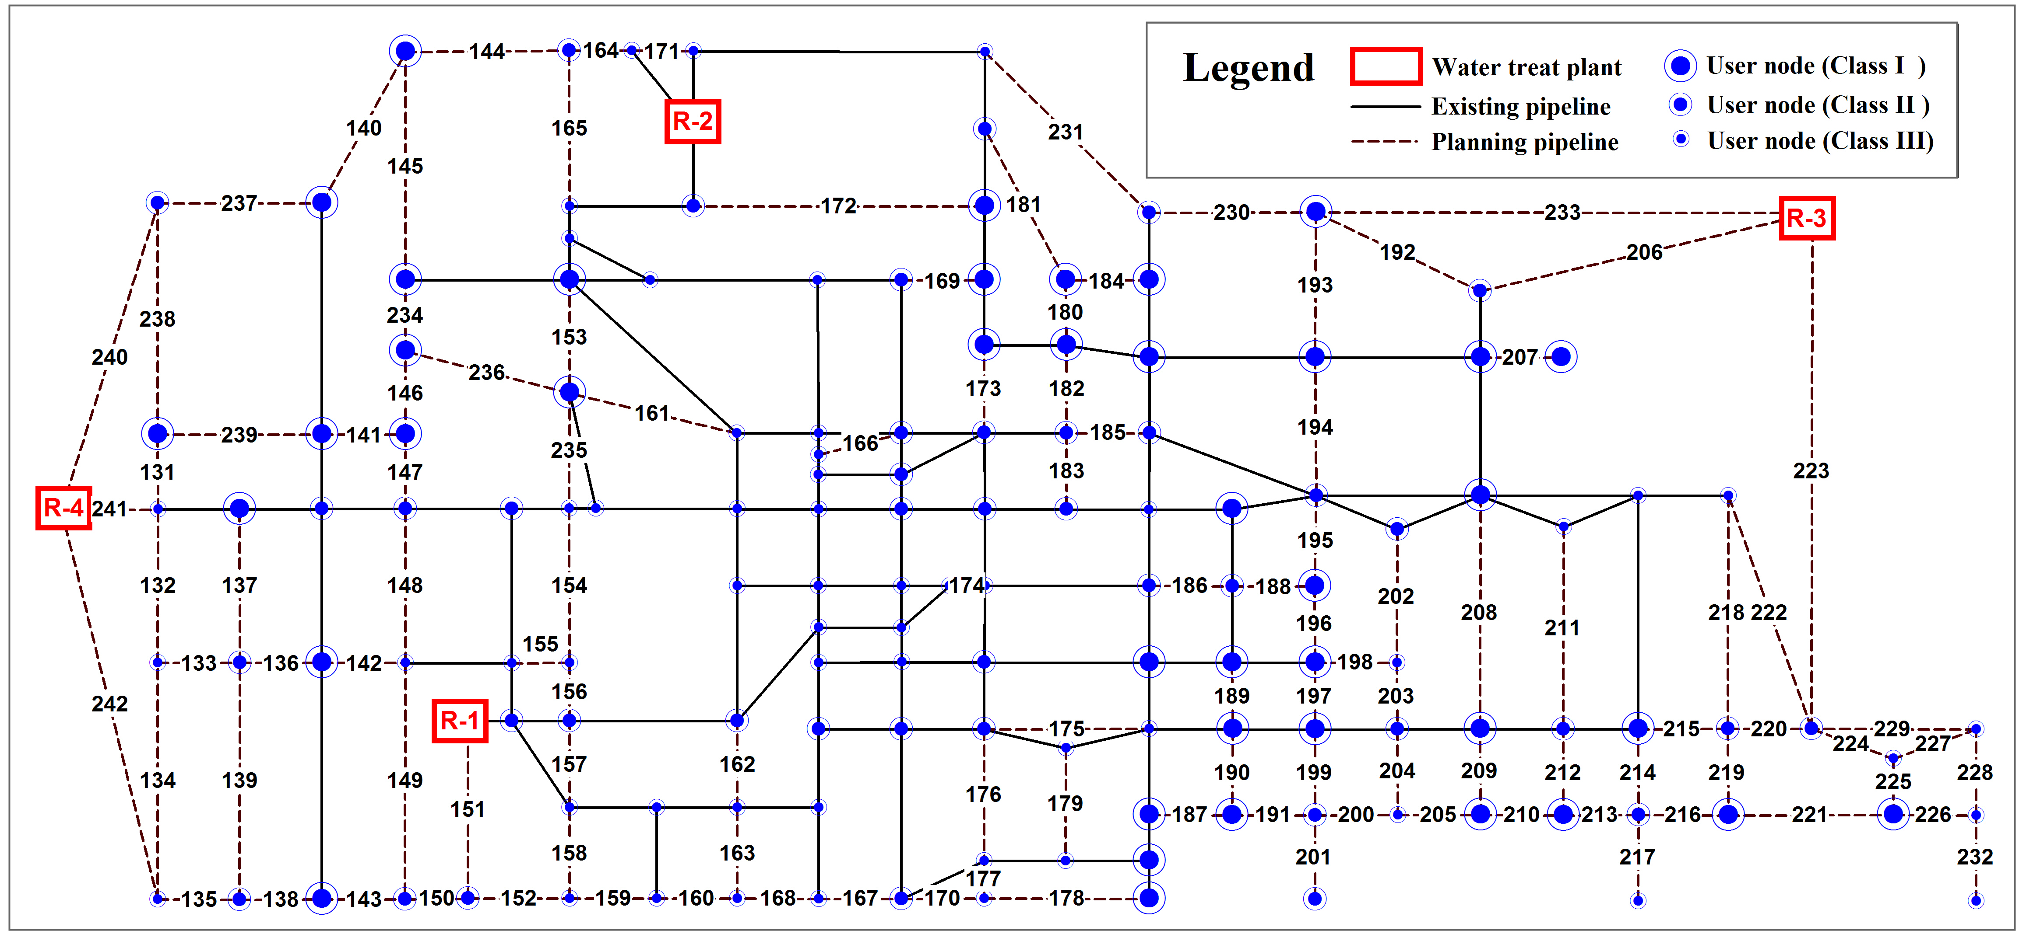

**Fig. 10** WDS network topology of Zhangzhou city and comprehensive importance classification of user nodes

## 5.1 Importance classification of user nodes

The water demands for the daily operation of user nodes were calculated according to the land type method in section 2. Land types in the service area of the pipeline network, provided by the overall urban planning, are shown in Fig. 11. The service areas of the user nodes divided by Thiessen polygons are also presented in Fig. 11. Planned water treatment plants R-3 and R-4 are located outside the service area of the WDS network, so are not included in Fig. 11. To show the network topology clearly, locations of the nodes and lengths of the pipelines are not shown proportionally in Fig. 10. However, in Fig. 11, the locations of the user nodes are shown by their geographical coordinates to calculate the water demands of user nodes in their service areas, and the areas of lands are also shown proportionally. Parameters *ni*, *Aij* and *mi* of the user nodes used to calculate the post-earthquake water demands (expression (1)) were determined according to geographical information in Fig. 11, and the standard daily unit demands *qj* of different land types are shown in Table 5 according to the Chinese code for urban water supply engineering planning (1998). The daily water demands of user nodes for normal operation were calculated by those values; demands in residential lands were classified as household demand, demands in public service lands, special spaces and municipal lands were classified as public service demand, demands in industrial lands and warehouse lands were classified as industrial demand, and demands in the other lands in Fig. 11 were treated as other types of demand.

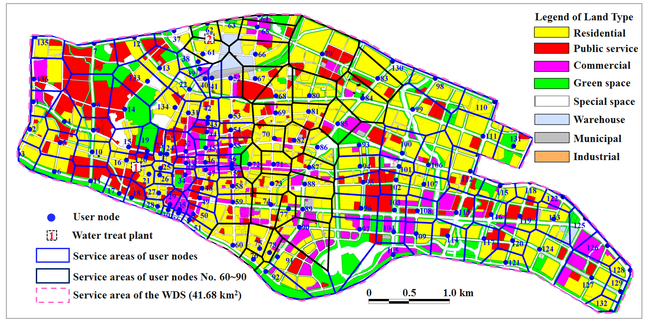

**Fig. 11** Service area zonation of user nodes according to land type in the service area of the experimental WDS

The post-earthquake demands of user nodes for disaster relief function were calculated by expression (1) and Table 1 based on the adjustment coefficient *αj* presented in Table 5 and parameters *ni*, *Aij*, *mi* and *qj*. The values of *αj* in Table 5 are values recommended by the authors according to a post-earthquake survey in China. Taking the 2008 Wenchuan earthquake as an example (Liu and Zheng 2013), the downtown areas of Mianzhu city suffered serious damage with Chinese SI IX. The water demands in this area were approximately 30 percent of the daily demands for normal operation for 30 days after the earthquake, and the post-earthquake water demands were mainly concentrated in disaster shelters for evacuation located in green spaces and open spaces in suburban areas.

**Table 5** Daily water demands and post-earthquake adjustment coefficients

|  |  |  |  |  |  |
| --- | --- | --- | --- | --- | --- |
| **Land type** | *qj* (1000 m3/ km2.day) | *αj* | **Land type** | *qj* (1000 m3/ km2.day) | *αj* |
| Residential | 19 | 0.3 | Special space | 10 | 1.0 |
| Public service | 10 | 2.0 | Warehouse | 3.5 | 1.0 |
| Commercial | 10 | 0.3 | Municipal | 10 | 2.0 |
| Green space | 2.0 | 5.0 | Industrial | 20 | 0.3 |

The water demand proportions of sub-indexes *I*1*j* and *I*2*j* of each user node are displayed in Fig. 12(a) and 12(b), respectively. According to the overall urban planning of Zhangzhou city, large industrial enterprises and reserves of hazardous materials (e.g., fuel and gas) are located in suburban areas and are not part of the downtown service areas of the WDS network. Therefore, the daily industrial water demands (*I*12) and post-earthquake water demands for secondary disaster control (*I*22) take a very small proportion of the water demands of the user nodes in Fig. 12. According to the constitutive rules of post-earthquake water demand in Table 1, user nodes holding a high proportion of residential water demand in Fig. 12(a) are converted to user nodes holding a high proportion of other demands in Fig. 12(b), while user nodes holding a high of on public service demands in Fig. 12(a) are converted to user nodes holding a high proportion of demand for disaster relief facilities and seismic shelters for evacuation in Fig. 12(b).





**Fig. 12** Water demand proportions of user nodes. **(a)** water demands for normal operation (I1). **(b)** water demands for post-earthquake relief function (I2).



**Fig. 13** Normalized values of sub-indexes for network topology importance (*I*3)

The values of sub-indexes *I*3*j* (*j*=1, 2, 3) were calculated by expressions (2) to (4) based on the WDS network topology and the geographical length of the pipelines. Because the value dimensions of sub-indexes *I*3*j* are different, the normalized values of those sub-indexes were calculated and are presented in Fig. 13. The weights of sub-indexes *I*3*j*, calculated by the IE method based on the values in Fig. 13 are {0.4833, 0.2915, 0.2252} for {*I*31, *I*32, *I*33}. The integrated weights of those sub-indexes are {0.1208, 0.0729, 0.0563}, based on the weight of the main index *I*3 (0.25). According to the IE method, an index holds a higher degree of dispersion if its values take higher values of weight. As shown in Fig. 13, the values of the betweenness centrality (*I*32) hold a higher degree of dispersion than those of the contraction centrality (*I*33), and the weight of *I*32 is accordingly greater than that of *I*33. Based on the weights and sub-index values presented in Fig. 12 and Fig. 13, the integrated importance for normal operation function, post-earthquake relief function and network topology calculated by the TOPSIS method are shown in Fig. 14(a), 14(b) and 14(c), respectively. Fig. 14(d) presents the comprehensive importance of user nodes, including all sub-indexes calculated by the TOPSIS method. Sort those coupling importance values in descending order, and take the 30% and 60% fractile values as boundaries to classify the importance classes of user nodes into I, II and III, and the corresponding results are shown in Fig. 14(a) to 14(d). A comprehensive importance classification of user nodes is also illustrated in Fig. 10.

 

 

**Fig. 14** Node importance values calculated by TOPSIS and their classification. **(a)** normal service function (*I*1). **(b)** post-earthquake relief function. **(c)** network topology influence. **(d)** comprehensive importance of all indexes.

A comparison between Fig. 14(a) and 14(b) indicates that the changes in the importance values over node numbers are similar. There is a concentration of low values between nodes 30 and 40. The average importance values between nodes 85 and 95 hold relatively higher values. However, there are also some differences between Fig. 14(a) and 14(b). From nodes 60 to 90, the numbers of user nodes in classes {I, II, III} are {11, 15, 5}, as shown in Fig. 14(a), while the corresponding numbers in Fig. 14(b) are {6, 14, 11}. There are noticeable differences in the numbers of user nodes in classes I and III between Fig. 14(a) and 14(b). The reason for these differences can be explained through the land types in the service areas of nodes 60 to 90 (Fig. 11). The service areas of these nodes are almost entirely composed of residential lands. The water demands of these nodes are relatively high for normal operation service, but they change to small values after an earthquake due to the movement of people from residential areas to shelters for evacuation. The numbers of nodes 60 to 90 in importance grades {I, II, III} are {8, 10, 13} in Fig. 14(c), which indicate the different emphases of the network topology indexes and other indexes consisting of water demand. Topological indexes mainly reflect a node’s impacts on the network connectivity. The numbers of nodes 60 to 90 in comprehensive importance grades {I, II, III} are {9, 11, 11} in Fig. 14(d), which are different from those of Fig 14(a) and 14(b). Therefore, the importance classifications of user nodes by comprehensive importance measures are different from those by importance indexes of a single type. The classifications of normal service importance and network topology influence importance cannot identify important nodes for post-earthquake disaster mitigation, and the classifications provided only by the importance indexes of post-earthquake relief function may not be practical for normal service. The classifications of comprehensive measures are more reasonable than those of any single index.

## 5.2 Seismic performance-based design of planning pipelines

The seismic connectivity reliability and redundancy (node degree) requirements are set to{0.90, 0.85, 0.80} and {2, 2, 1} for user nodes in classes {I, II, III}, respectively. Because nodes 105, 121, 131 and 132 are connected by a single line in the alternative pipeline network, the redundancy requirements of these nodes were changed to 1. The reliability requirement of node 131 was replaced by 0.85. For the pipeline network in Fig. 10, the seismic reliabilities of the existing pipelines are assumed to be 0.80 and are maintained unchanged, and the possible seismic reliabilities of each planning pipeline were assumed to be {0.85, 0.90 (reference), 0.95}, corresponding to the possible options of pipeline materials and joints. The corresponding possible values of the cost adjustment coefficients *φi* were assumed to be {0.9, 1.0 (reference), 1.2} for each planning pipeline.

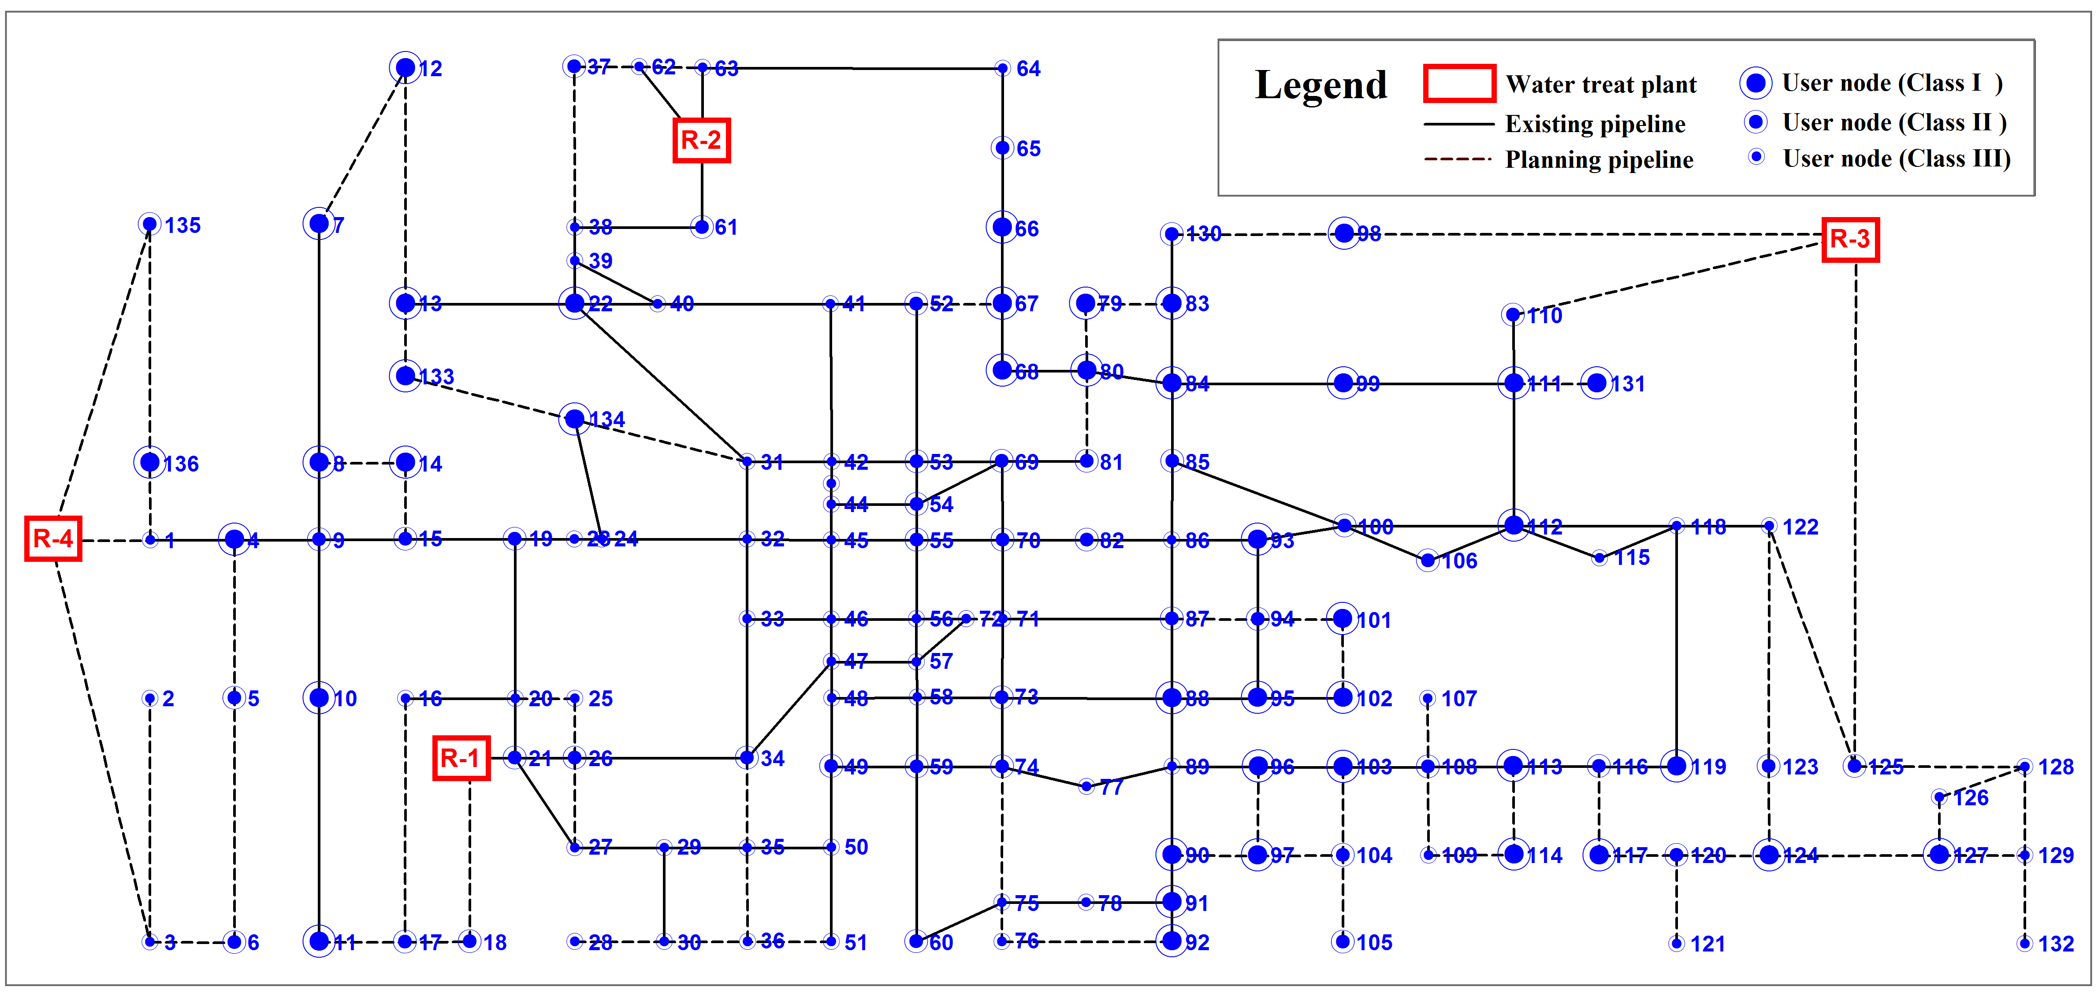

**Fig. 15** Optimal layout of pipeline network satisfying seismic performance requirements of user nodes

Based on the existing network topology and alternative layout of the planning pipelines, we employ the optimization model to determine the routes and seismic capacities of the pipelines that fulfill the seismic performance requirements of the user nodes. The optimization model was solved by SAGA, and the maximum generation was set as 200 to stop the evolution of SAGA. The optimal layouts of the pipelines are illustrated in Fig. 15. The corresponding cost adjustment coefficients related to the seismic reliabilities of the pipelines are presented in Fig. 16. The reference cost of each possible pipeline is also presented in Fig. 16. It should be noted that the reference costs of pipelines {206, 223, 233} are {29.92, 44.03, 18.22} million RMB; these costs are displayed at a value of 7.0 million RMB for display convenience. The total cost of all of the selected pipelines in the WDS network is 153.68 million RMB. In Fig. 16, the optimal selection of pipeline layouts is presented by the items “CC-higher”, “CC-reference” and “CC-lower”, where “CC” is an abbreviation for the “changed capacity” condition, corresponding to the seismic reliability variety of pipelines. The seismic reliability of each selected pipeline is indirectly presented by its cost adjustment coefficient. As shown in Fig. 16, the items “CC-higher”, “CC-reference” and “CC-lower” of the selected pipelines correspond to cost adjustment coefficients of 1.2, 1.0 and 0.9, respectively and also seismic reliabilities of 0.95, 0.90 and 0.85 of the selected pipelines, respectively.



**Fig. 16** Reference cost of pipelines, optimal pipeline selections and corresponding adjustment coefficients

Figure 16 also presents the optimal pipeline selection for the condition that ignores the seismic resistance variation of planned pipelines, named the “unchanged capacity” (UC) condition. In the UC condition, the seismic reliability and cost adjustment coefficient of each pipeline are assumed to have pre-determined values of 0.90 and 1.0, respectively. The selected pipelines of the UC condition are presented by the “UC selection” items in Fig. 16. The total cost of this condition is 162.20 million RMB. Therefore, the optimal design results of the performance-based design model considering the seismic resistance variation of planned pipelines is not only consistent with the actual options in practice but also reduces the total cost.

As shown in Fig. 16, in the design selections of the CC condition, the pipelines with higher reference costs were assigned lower cost adjustment coefficients corresponding to lower seismic capacity requirements; for example, the *φi* values of pipelines {206, 223, 233} were set to 0.90, and the *φi* values of pipelines {161,182,240} were set to 1.20. Therefore, the optimization algorithm GASA is effective and feasible for the optimization model.

The selections of planned pipelines presented in Fig. 15 can be regarded as trunk lines for seismic disaster mitigation purpose sin the pipeline network planning of WDS with a high level of priority. The materials, joints and constructions of these pipelines should be determined according to the seismic reliability requirements of pipeline structures. The planned pipelines that were not chosen by the optimization model and ae excluded from Fig. 10, named “other pipelines”, should be constructed to fulfill the daily water supply requirements of the WDS without special consideration of seismic design.

# 6 Conclusions and Discussion

This paper proposed a framework for the seismic performance-based design of WDSs, as implemented by an optimization design model of the pipeline network. The seismic design objectives of the WDS are represented by the seismic reliability and redundancy requirements of the user nodes. The design variables consist of the topology of the WDS network and the seismic resistance capacity of the pipeline structures. A comprehensive assessment method to evaluate the importance of user nodes was presented. An improved seismic optimization design model was presented to consider the importance of the variation of user nodes as well as the seismic resistance capacity differences of pipelines. In a case study, the proposed model was implemented in the seismic design of a planning WDS network. The following conclusions can be made from the application results:

(1) The importance classifications of user nodes by comprehensive importance measures are different from those by individual importance indexes; the classifications by normal service importance and network topology influence importance cannot identify important nodes for post-earthquake disaster mitigation.

(2) The optimal design results that consider the variations of the seismic capacity of pipeline structures are not only consistent with the actual options in practice but also reduce the construction cost of pipelines.

(3) The optimal topology layouts and seismic capacities of pipelines obtained by the proposed performance-based design model allow the network topology and pipeline structures to meet the requirements to secure the post-earthquake serviceability of the WDS and can be treated as the basis for the seismic fortification and retrofitting of the WDS.

It should be noted that the seismic security of the WDS should be ensured by not only the network redundancy and seismic resistance of pipeline structures but also by the seismic safety of WDS facilities, including wells, water treatment plants, and pumping stations. The scope of this paper focuses on the seismic safety of pipeline structures and the pipeline network topology, but seismic countermeasures for WDS facilities should be considered in further studies.

# Acknowledgements

This study is supported by the Natural Science Foundation of China (NSFC) under Grant Nos. 51508528, 51421005, 51208017 and 51278017. Any opinions, findings, and conclusions expressed in this paper are those of the authors and do not necessarily reflect the views of the NSFC.

# References

American Lifelines Alliance (ALA). (2005). Seismic guidelines for water pipelines.

Brandes, U. (2001). A faster algorithm for betweenness centrality. Journal of mathematical sociology, 25(2), 163-177.

Certa, A., Enea, M., Galante, G., & Lupo, T. (2013). A multi-decision makers approach to select the maintenance plan for a multi-component system. In Proceeding of 19th ISSAT international conference on reliability and quality in design.

Chen, L. L., Li, J., & Xu, C. C. (2002). Seismic reliability-based optimization for water supply network. In Proceeding of the 9th International Conference on Computing in Civil and Building Engineering, Taipei, China (pp. 793-798).

China Earthquake Administration (CEA). (2015). Seismic Ground Motion Parameter Zonation Map of China. Beijing: China Standard Press, 2015. (in Chinese)

Ditlevsen, O., & Madsen, H. O. (1996). Structural reliability methods (Vol. 178). New York: Wiley.

Dueñas-Osorio, L., & Vemuru, S. M. (2009). Cascading failures in complex infrastructure systems. Structural safety, 31(2), 157-167.

Ganzerli, S., Pantelides, C. P., & Reaveley, L. D. (2000). Performance-based design using structural optimization. Earthquake engineering & structural dynamics, 29(11), 1677-1690.

Ghobarah, A. (2001). Performance-based design in earthquake engineering: state of development. Engineering structures, 23(8), 878-884.

Guo, E. D., Liu, R. S., & Sun, B. T. (2007). Gradation criterion of earthquake damage to buried pipeline engineering. Journal of Natural Disasters, 16(4), 86-90. (in Chinese)

Hoshiya, M., Yamamoto, K., & Ohno, H. (2004). Redundancy index of lifelines for mitigation measures against seismic risk. Probabilistic engineering mechanics, 19(3), 205-210.

Indian Institute of Technology Kanpur & Gujarat State Disaster Management Authority (IITK-GSDMA). (2007). Guidelines for seismic design of buried pipelines.Japan Water Works Association (JWWA). (2009). Seismic design guideline for water systems. (in Japanese)

Jung, D., Kang, D., Kim, J. H., & Lansey, K. (2013). Robustness-based design of water distribution systems. Journal of Water Resources Planning and Management, 140(11), 04014033.

Kadu, M. S., Gupta, R., & Bhave, P. R. (2008). Optimal design of water networks using a modified genetic algorithm with reduction in search space. Journal of Water Resources Planning and Management, 134(2), 147-160.

Kapelan, Z. S., Savic, D. A., & Walters, G. A. (2005). Multiobjective design of water distribution systems under uncertainty. Water Resources Research, 41(11).

Kim, G., Park, C. S., & Yoon, K. P. (1997). Identifying investment opportunities for advanced manufacturing systems with comparative-integrated performance measurement. International Journal of Production Economics, 50(1), 23-33.

Li, J. (2005). Lifeline Earthquake Engineering-basic Methods and Applications. Beijing: Science Press. (in Chinese)

Li, J., & Liu, W. (2008). Seismic reliability analysis and topology optimization of lifeline networks. In 14th World Conference on Earthquake Engineering, Beijing, Paper (pp. 06-0145).

Li, J., Liu, W., & Bao, Y. (2008). Genetic algorithm for seismic topology optimization of lifeline network systems. Earthquake engineering & structural dynamics, 37(11), 1295-1312.

Lim, H. W., & Song, J. (2012). Efficient risk assessment of lifeline networks under spatially correlated ground motions using selective recursive decomposition algorithm. Earthquake Engineering & Structural Dynamics, 41(13), 1861-1882.

Liu S., & Zheng X. (2013). Damage and disaster relief activity survey of water supply system in the 2008 Wenchuan Earthquake. Shanghai: Tongji University Press. (in Chinese)

Liu, W., Xu, L., & Li, J. (2012). Algorithms for seismic topology optimization of water distribution network. Science China Technological Sciences, 55(11), 3047-3056.

Liu, W., Zhao, Y., & Li, J. (2015). Seismic functional reliability analysis of water distribution networks. Structure and Infrastructure Engineering, 11(3), 363-375.

Mukherjee, A., & Nath, P. (2005). An empirical assessment of comparative approaches to service quality measurement. Journal of Services Marketing, 19(3), 174-184.

National Standard of China. (GB50032 2003). Code for seismic design of outdoor water supply, sewerage, gas and heating engineering. Beijing: China Planning Press, 2003. (in Chinese)

National Standard of China. (GB50282 1998). Code for urban water supply engineering planning. Beijing: China Architecture & Building Press, 1998. (in Chinese)

National Standard of China. (GB50413 2007). Standard for urban planning on earthquake resistance and hazardous prevention. Beijing: China Architecture & Building Press. (in Chinese)

National Standard of China. (GB50470 2008). Seismic technical code for oil and gas transmission pipeline engineering. Beijing: China Planning Press. (in Chinese)

O’Rourke, M. J., & Liu, X. (2012). Seismic design of buried and offshore pipelines. Multidisciplinary Center for Earthquake Engineering Research, Monograph, MCEER-12-MN04.

Ramirez-Marquez, J. E., & Coit, D. W. (2005). A Monte-Carlo simulation approach for approximating multi-state two-terminal reliability. Reliability Engineering & System Safety, 87(2), 253-264.

Romero, N., O'Rourke, T. D., Nozick, L. K., & Davis, C. A. (2010). Seismic hazards and water supply performance. Journal of Earthquake Engineering, 14(7), 1022-1043.

Tan, R., & Shinozuka, M. (1982). Optimization of underground water transmission network systems under seismic risk. International Journal of Soil Dynamics and Earthquake Engineering, 1(1), 30-38.

Tan, Y. J., Wu, J., & Deng, H. Z. (2006). Evaluation method for node importance based on node contraction in complex networks. Systems Engineering-Theory & Practice, 11(11), 79-83. (in Chinese)

Wang, S. W., Wang, Y., Qian, Z. H., Liu, S. Q., Yuan, W. Q., & Zheng, X. M. (2009). Investigation and Analysis about Damage and Recovery of Water Supply System in 5.12 Earthquake Areas. China Water & Wastewater, 25(7), 1-6. (in Chinese)

Wang, Y., Au, S. K., & Fu, Q. (2010). Seismic risk assessment and mitigation of water supply systems. Earthquake Spectra, 26(1), 257-274.

West, D. B. (2001). Introduction to graph theory (Vol. 2). Upper Saddle River: Prentice hall.

Winkler, J., Duenas-Osorio, L., Stein, R., & Subramanian, D. (2010). Performance assessment of topologically diverse power systems subjected to hurricane events. Reliability Engineering & System Safety, 95(4), 323-336.

Yoo, D. G., Kang, D., & Kim, J. H. (2016). Optimal design of water supply networks for enhancing seismic reliability. Reliability Engineering & System Safety, 146, 79-88.

Zhu Y., Meng Z. Y., & Kan S. Y. (1999). Determination of weight value by AHP. Journal of Northern Jiaotong University, 23(5), 119-122. (in Chinese)

Zou, Z. H., Yi, Y., & Sun, J. N. (2006). Entropy method for determination of weight of evaluating indicators in fuzzy synthetic evaluation for water quality assessment. Journal of Environmental Sciences, 18(5), 1020-1023.